**Nathan Flack**

**CSCE 560 Homework 4**

**Chapter 4 – Network Layer**

**Fall 18**

**Assigned: Monday, 5 Nov**

**Due: Monday, 19 Nov, 1400**

**Problem 1**. Chapter 4, R2

We noted that network layer functionality can be broadly divided into data plane functionality and control plane functionality. What are the main functions of the data plane? Of the control plane?

*Data plane: the data plane is concerned with forwarding packets that arrive to the router to the correct output link based on current state of the routing table.*

*Control plane: This plane routes packets through the network. The control plane must determine the route or path taken by packets as they flow from sender to receiver. It builds the routing tables, based on routing algorithms that are used by the data plane to route packets.*

**Problem 2**. Chapter 4, R3

We made a distinction between the forwarding function and the routing function performed in the network layer. What are the key differences between routing and forwarding?

*Forwarding is concerned with moving packets from the input link to the appropriate output link of the router in question.*

*Routing is the determination of the route or path taken by a packet as it moves from sender to receiver. These paths are calculated by routing algorithms.*

**Problem 3**. Chapter 4, R17

Suppose Host A sends Host B a TCP segment encapsulated in an IP datagram. When Host B receives the datagram, how does the network layer in Host B know it should pass the segment (that is, the payload of the datagram) to TCP rather than to UDP or to some other upper-layer protocol?

*The upper layer protocol field (8 bits) in the IP datagram header contains the information about which transport layer protocol the destination host should target for the segment.*

**Problem 4**. Chapter 4, R18

What field in the IP header can be used to ensure that a packet id forwarded through no more than N routers?

*The Time to Live (TTL) sets the max number of hops, which is decremented at each router.*

**Problem 5**. Chapter 4, R21

Do routers have IP addresses? If so, how many?

*Yes, routers have an IP address for every interface on the device.*

**Problem 6**. Chapter 4, R22

What is the 32-bit binary equivalent of the IP address 223.1.3.27?

*1101111 00000001 00000011 00011011*

**Problem 7**. Chapter 4, R24

Suppose there are three routers between a source host and a destination host. Ignoring fragmentation, an IP datagram sent from the source host to the destination host will travel over how many interfaces? How many forwarding tables will be indexed to move the datagram from the source to the destination?

*Interfaces: 8 (host NIC, two for each router (2 * 3 = 6), and the destination NIC)*

*Forwarding tables: 3 (one for each router)*

**Problem 8**. Chapter 4, R25

Suppose an application generates chunks 40 bytes of data every 20 msec, and each chunk gets encapsulated in a TCP segment and then an IP datagram. What percentage of each datagram will be overhead, and what percentage will be application data?

*20 bytes of overhead for each packet for the TCP segment header*

*20 bytes of overheard for each packet for the IP datagram header*

*Total Datagram size = data + TCP header + IP header = 20 + 20 + 20 = 60 bytes total*

*Percentage that is overhead: 66.6% (40/60)*

*Percentage that is application data: 33.3% (20/60)*

**Problem 9**. Chapter 4, R26

Suppose you purchase a wireless router and connect it to your cable modem. Also suppose that your ISP dynamically assigns your connected device (that is, your wireless router) one IP address. Also suppose that you have five PCs at home that use 802.11 to wirelessly connect to your wireless router. How are IP addresses assigned to the five PCs? Does the wireless router use NAT? Why or why not?

*The wireless router (acting as the DHCP server) assigns the 5 PCs each a unique IP address in the “Private IP address range (10.0.0.0 – 10.255.255.255, 172.16.0.0 – 172.31.255.255, and 192.168.0.0 – 192.168.255.255).*

*The wireless router then uses NAT to assign all datagrams leaving your home the same source IP address (this is the one assigned by the ISP). The router then remembers each of the connections (in a NAT translation table) so that it can route the return traffic to the correct PC. The router replaces all destination IPs in the incoming datagrams with the correct destination IP and port # from the NAT translation table.*

**Problem 10**. Chapter 4, R32

How does generalized forwarding differ from destination-based forwarding?

*Destination-based forwarding bases all forwarding decisions on the destination IP field in the IP header. (Based on what is in the forwarding table).*

*Generalized forwarding refers to packet routing using simple rules on values in any packet header field. Therefore, it is more versatile than basic destination-based forwarding. Devices can take on some firewall or other device functionality.*

**Problem 11**. Chapter 4, P5

Consider a datagram network using 32-bit host addresses. Suppose a router has four links, numbered 0 through 3, and packets are to be forwarded to the link interfaces as follows:

Destination Address Range Link Interface

11100000 000 00000 00000000 00000000 0

11100000 00111111 11111111 11111111

11100000 01000000 00000000 00000000 1

11100000 01000000 11111111 11111111

11100000 01000001 00000000 00000000 (224.65.0.0)

through 2

11100001 01111111 11111111 11111111 (225.127.255.255)

Otherwise 3

1. Provide a forwarding table that has four entries, uses longest-prefix matching, and forwards packets to the correct link interfaces. "Otherwise" does not count as one of the four entries. In other words, you should have four entries with prefixes in your table in addition to "Otherwise" for a total of five rows/entries.

Prefix: Link Interface:

11100000 00 0

11100000 01000000 1

11100000 2

11100001 0 2

Otherwise 3

b. Describe how your forwarding table determines the appropriate link interface for datagrams with the following destination addresses. Be sure to actually list the interface used for each datagram.

*The forwarding table looks at the highlighted bits to determine what interface to send it out on.*

11001000 10010001 01010001 01010101 (Otherwise - Interface 3)   
11100001 01000000 11000011 00111100 (Matched to 4th line - Interface 2)  
11100001 10000000 00010001 01110111 (Otherwise - Interface 3)

11100000 01000000 00010001 01110111 (Matched to 2nd line - Interface 1)

11100000 00010001 01010001 01010101 (Matched to 1st line - Interface 0)  
(223.0.16.1) 11011111 00000000 00010000 00000001 (Otherwise - Interface 3)

(224.253.1.1) 11100000 11111101 00000001 00000001 (Matches to 3rd line - Interface 2)

**Problem 12**. Chapter 4, P6

Consider a datagram network using 8-bit host addresses (e.g., 10101111); we are not using 32-bit IP addresses. Suppose a router uses longest prefix matching and has the following forwarding table:

Prefix Match Interface

00 (0-63) 0

010 (64 - 95) 1

011 (96- 127) 2

10 (128 - 191 2

11 (192 – 255) 3

*For each of the four interfaces, give the associated range of destination host addresses in binary and decimal and the total number of addresses for each interface.*

|  |  |  |  |
| --- | --- | --- | --- |
| Interface | Binary | Decimal | Total # of Addresses |
| 0 | 00000000 – 00111111 | 0 – 63 | 64 |
| 1 | 01000000 – 01011111 | 64 – 96 | 32 |
| 2 | 01100000 – 10111111 | 96 – 191 | 96 |
| 3 | 11000000 – 11111111 | 192-255 | 64 |

**Problem 13**. Chapter 4, P11

Consider a subnet with prefix 128.119.40.128/26. Give an example of one IP address (of form xxx.xxx.xxx.xxx) that can be assigned to this network. Suppose an ISP owns the block of addresses of the form 128.119.40.64/26. Suppose it wants to create four subnets from this block, with each block having the same number of IP addresses. What are the prefixes (of form a.b.c.d/x) for the four subnets?

*Any IP from 128.119.40.128 - 128.119.40.191*

*Prefixes for Subnets :*

*128.119.40.64/28 (16 IPs)*

*128.119.40.80/28 (16 IPs)*

*128.119.40.96/28 (16 IPs)*

*128.119.40.112/28 (16 IPs)*

**Problem 14**. Chapter 5, R4

Compare and contrast link state and distance vector routing algorithms. What information is transmitted and to whom by each router?

*Link State: Each node in the network broadcasts its link-state information to all other nodes in the network.*

*Distance-Vector: Each node sends the route information it knows at the time to only its neighbors.*

**Problem 15**.

Consider the network shown below, and assume that each node initially knows the costs to each of its neighbors. Consider the distance vector algorithm and show the distance table entries at node z. Be sure to show how ALL node entries change over time. Finally, show the forwarding table for node z after the algorithm completes.



**Distance table entries on next page.**

**Forwarding Table for Node z:**

|  |  |
| --- | --- |
| **Destination** | **Link** |
| **u** | **(z,v)** |
| **v** | **(z,v)** |
| **x** | **(z,x)** |
| **y** | **(z,x)** |

|  |  |  |  |  |  |  |
| --- | --- | --- | --- | --- | --- | --- |
| *Node z* |  | **Cost to** | | | | |
|  |  | u | v | x | y | z |
| **From** | u | 0 | 4 | 12 | 11 | 9 |
|  | v | 4 | 0 | 7 | 7 | 5 |
|  | x | 11 | 7 | 0 | 1 | 2 |
|  | y | 11 | 7 | 1 | 0 | 3 |
|  | z | 9 | 5 | 2 | 3 | 0 |

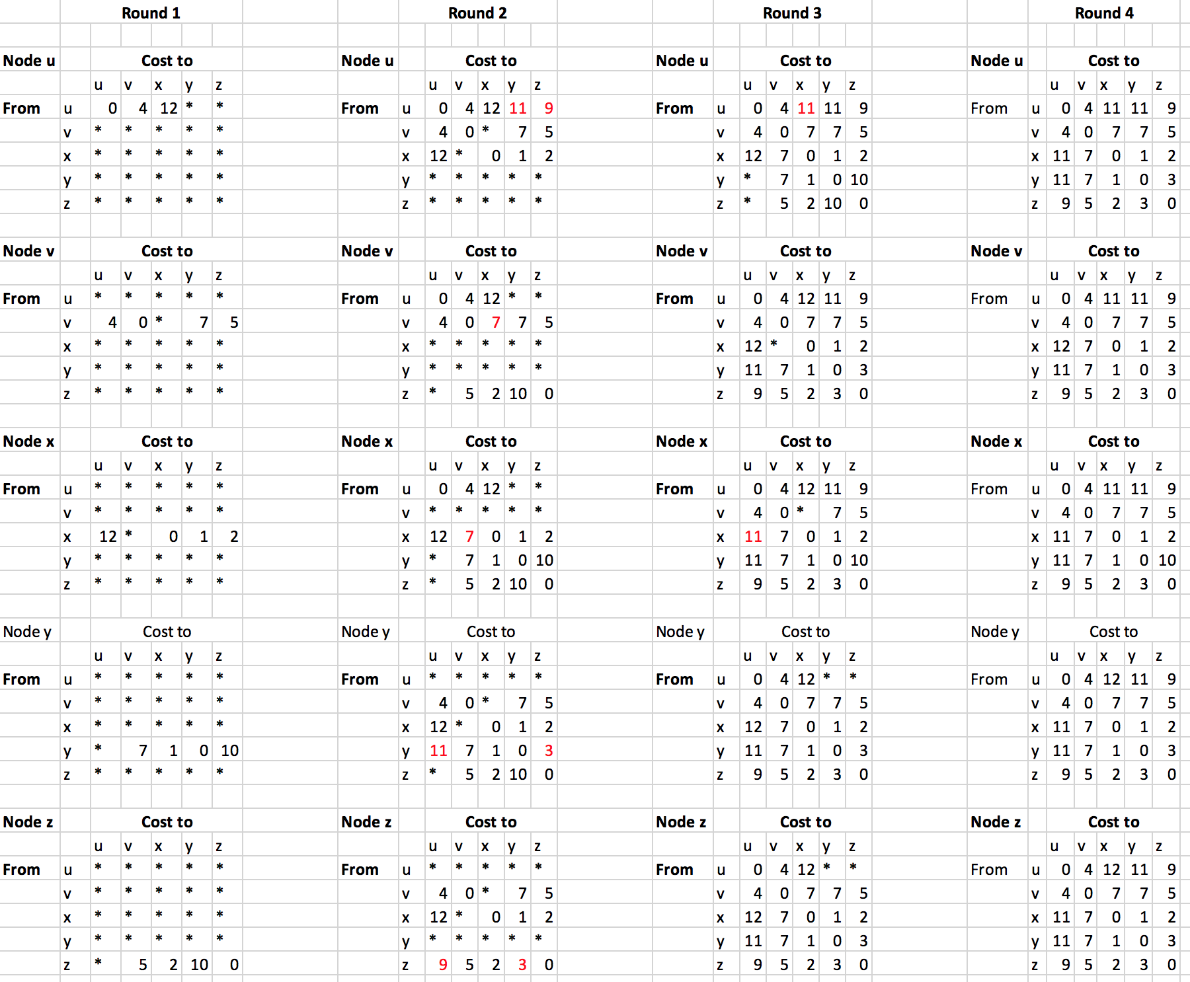

**Problem 16**.

Consider the following network. With the indicated link costs, use Dijkstra's shortest-path algorithm to compute the shortest path from x to all network nodes. Show how the algorithm works by computing a table similar to Table 4.3. Use the table given below; do not change the column headings. You may not need all rows shown. Finally, show the forwarding table for node x after the algorithm completes; remember the forwarding table is derived from the table used in completing the algorithm.

***Note: *=infinity***

|  |  |  |  |  |  |  |  |  |
| --- | --- | --- | --- | --- | --- | --- | --- | --- |
| Step | N' | D(s),p(s) | D(t),p(t) | D(u),p(u) | D(v),p(v) | D(w),p(w) | D(y),p(y) | D(z),p(z) |
| 0 | x | * | * | * | 3,x | 6,x | 6,y | * |
| 1 | xv | * | 7,v | 6,v |  | 6,x | 4,v | * |
| 2 | xvy | * | 7,v | 6,v |  | 6,x |  | 16,y |
| 3 | xvyu | 10,u | 7,v |  |  | 6,x |  | 16,y |
| 4 | xvyuw | 10,u | 7,v |  |  |  |  | 16,y |
| 5 | xvyuwt | 8,t |  |  |  |  |  | 12,t |
| 6 | xvyuwts |  |  |  |  |  |  | 12,t |
| 7 | xvyuwtsz |  |  |  |  |  |  |  |
| 8 |  |  |  |  |  |  |  |  |
| 9 |  |  |  |  |  |  |  |  |

Forwarding table:

The last column is technically not a part of the forwarding table, but it will help you determine the appropriate output link.

|  |  |  |
| --- | --- | --- |
| Destination | Link | Path from destination back to x |
| s | (u,v) | s to t to v to x |
| t | (u,v) | t to v to x |
| u | (u,v) | u to v to x |
| v | (u,v) | v to x |
| w | (u,w) | w to x |
| y | (u,v) | y to v to x |
| z | (u,v) | z to t to v to x |